FINAL EXAMINATION . TIME ALLOWED: 90’
Subject: Linear Algebra. No books allowed.

1/ Find the matrix , such that 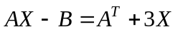, where 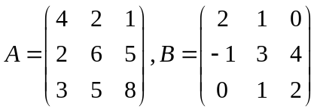.

2/ Determine all real values of m for which det(A) = 3, where 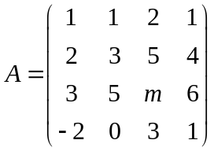.

3/ Solve the linear system of equations AX = b, given that
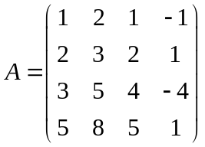 and 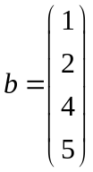

4/ In 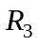 with the inner product , given the subspace 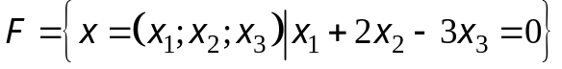.
Find one basis and a dimension of the orthogonal compliment 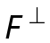 of the subspace F.

5/ Let 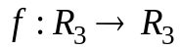 be the linear transformation.
Assume that .
a/ 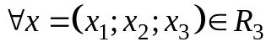, find 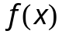.
b/ Find one basis and a dimension of the kernel of the mapping 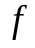.

6/ Let be the linear transformation and
.

a/ Find the matrix  of the transformation f in the basis 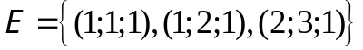.
b/ Using the matrix A, compute 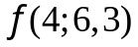.

7/ a/ Diagonalize the matrix 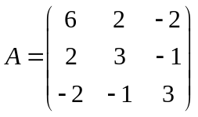, if possible.
b/ Compute 

  

